**Inverness**

**Taigh d'Luxe: Savour the HighLife in the Highlands (Airbnb)**

**Sunday May 24 – Tues. May 26 – 2 nights.**

Entire villa in Highland, United Kingdom

4 bedrooms, 4 beds, 3.5 baths

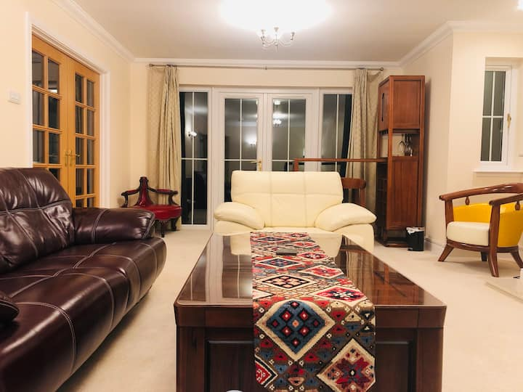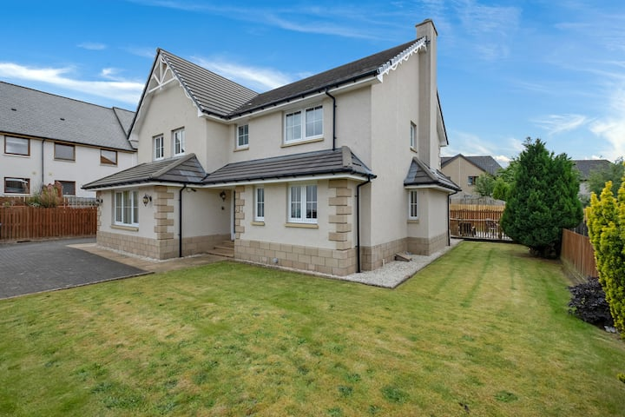

**About this space**

Taigh d'Luxe: Classic elegance meets modern chic in stunning spacious villa. Superbly located for Highland attractions- Loch Ness, Cairngorms National Park, NC 500, Whisky trails, golf tours and many others. Perfect for families & groups. Free parking, high speed wi-fi, super king beds, jacuzzi and bbq. Immaculately furnished with stylish opulence and warm comfort to pamper you. The lavish charm of this welcoming abode with high quality amenities, will be perfect for a dream holiday

**The space**

The detached, corner property is in a quiet residential area with excellent connectivity to all arterial road routes and places of interest. Supermarkets, fast food and retail outlets are in close proximity. Easily accessible, no matter what your preferred mode of transport to Inverness / the Highlands. Please see 'neighborhood' and 'getting around' tabs/sections for further details. Superfast wi-fi coverage throughout the house both upstairs and downstairs. Free parking with space for 2-3 cars on own driveway. We recommend guests use the driveway for ease and convenience.  
  
Furnished to a high standard, the luxury villa offers spacious accommodation over two floors and comprises on the ground floor:  
  
   
  
Living Room  
Spacious lounge with leather sofas, upholstered chairs, additional seating, gas fired fireplace, free-view TV, a slick bar space and French/patio doors leading to the rear garden  
  
Dining room  
Separate dining room with exquisite large dresser/cabinet, ample glassware, dining table and chairs, also with French / patio doors to rear garden

**Where you’ll sleep**

Bedroom 1- 1 king bed

Bedroom 2 - 1 king bed

Bedroom 3 - 1 king bed

Bedroom 4 – 1 queen bed